**JAVASCRIPT**

* Javascript statements will end in a semicolon(;)
  + Javascript statement examples:
    - Alert(“”);
      * Web page alerts user, dialog box
    - Console.log(“”);
      * Console will respond with the same string
    - Document.write(“”);
      * Console will open new page with same string
    - <https://teamtreehouse.com/workspaces/42176396>
  + JavaScript engine: a program (or interpreter) built into the browser that executed JavaScript code
  + Linking js file to an html file
    - <script src=”js/script.js”></script>
  + Variables: <https://developer.mozilla.org/en-US/docs/Web/JavaScript/Reference/Statements/var>
    - Naming Variables
      * Words you can’t used because they are reserved word <https://developer.mozilla.org/en-US/docs/Web/JavaScript/Reference/Lexical_grammar#keywords>
      * Variable names can begin with $ or _
        + <https://www.w3schools.com/js/js_variables.asp>
    - Addition assignment
      * <https://developer.mozilla.org/en-US/docs/Web/JavaScript/Reference/Operators/Addition_assignment>
      * var a = 2;

var b = 5;

console.log(a += b);

* + - using (let) & (const) instead of (var)
      * <https://developer.mozilla.org/en-US/docs/Web/JavaScript/Reference/Statements/let>
      * <https://developer.mozilla.org/en-US/docs/Web/JavaScript/Reference/Statements/const>
        + Cannot change or manipulate the value by reassignment and not able to redeclare a constant
  + Strings
    - <https://developer.mozilla.org/en-US/docs/Web/JavaScript/Guide/Text_formatting#strings>
      * Single or double quotes instruct the javascript engine that it should treat the contents inside as a regular set of characters
    - String: length
      * <https://developer.mozilla.org/en-US/docs/Web/JavaScript/Reference/Global_Objects/String/length>
        + The number of characters inside a string

console.log(nameOfVariable.length);

prints the amt of characters in thr javascript engine

* + - Strings are objects and you can access properties of an object using a (.)
    - Combining strings:
      * <https://developer.mozilla.org/en-US/docs/Learn/JavaScript/First_steps/Strings#concatenating_strings>
        + Const name = prompt(“what is your name?”);

Const message = “hello ” + name;

Console.log(message);

* + - * + let message = “hello”;

message = message + “nice to see you”;

message += “nice to see you”;

* + - Template literals:
      * <https://developer.mozilla.org/en-US/docs/Web/JavaScript/Reference/Template_literals>
        + `` = “” ‘’
        + String interpolation

<https://developer.mozilla.org/en-US/docs/Web/JavaScript/Reference/Template_literals#string_interpolation>

Const name = prompt(“what is your name?”);

Const message = `Hello, ${name}. It’s ${2 * 3} o’clock.`;

* + Methods
    - Methods, the () let the java engine know this is a method
      * console.log(nameOfVariable.toUpperCase() );
        + Transforms all of the characters to upper case in a string
      * console.log(nameOfVariable.toLowerCase() );
        + Transforms all of the characters to lower case in a string
      * Prompt();
        + <https://developer.mozilla.org/en-US/docs/Web/API/Window/prompt>
        + const varName = prompt(“”);
  + Query Selectors
    - <https://developer.mozilla.org/en-US/docs/Web/API/Document/querySelector>
    - querySelector(tag name, class or ID as a string);
      * document.querySelector(‘main’).innerHTML = varName;
        + will cause content to show up on HTML page
  + Conditional Statements
    - <https://developer.mozilla.org/en-US/docs/Web/JavaScript/Reference/Statements/if...else>
    - <https://developer.mozilla.org/en-US/docs/Learn/JavaScript/Building_blocks/conditionals>

* Else-if statements
  + <https://developer.mozilla.org/en-US/docs/Web/JavaScript/Reference/Statements/if...else#using_else_if>

* Comparison Operators
  + <https://developer.mozilla.org/en-US/docs/Web/JavaScript/Reference/Operators>
  + equality operator (==)
    - tests if two values are the same, makes some allowances of the values
      * ( ‘3’ == 3 ) true
  + strict equality operator (===)
    - compares the type as well as the value
      * ( ‘3’ === 3 ) false
  + Not equal (!=)
  + Strict inequality (!==)
* Boolean
  + Quotes should not go around Boolean values

* (+) if front of varName turns the string into a num if it isn’t already
  + <https://developer.mozilla.org/en-US/docs/Web/JavaScript/Reference/Operators/Unary_plus>
* && operator
  + <https://developer.mozilla.org/en-US/docs/Web/JavaScript/Reference/Operators/Logical_AND>
* || OR operator
  + <https://developer.mozilla.org/en-US/docs/Web/JavaScript/Reference/Operators/Logical_OR>

*JavaScript Numbers*

* <https://developer.mozilla.org/en-US/docs/Learn/JavaScript/First_steps/Math#types_of_numbers>
  + Scientific notation
    - 9e-6 // same as .000009
    - 9e+6 // same as 9,000,000
  + Integer
    - Whole numbers that can be positive or negative
  + Floating point numbers
    - Numbers with a decimal
* Math operators

* + <https://developer.mozilla.org/en-US/docs/Learn/JavaScript/First_steps/Math>
  + typeof
    - returns a string indicating the type of the operand’s value

* converting a string to a integer number
  + parseInt()
* converting a string to a float point
  + parseFloat()
* unary plus(+) works with integers & float point numbers
* math.
  + <https://developer.mozilla.org/en-US/docs/Web/JavaScript/Reference/Global_Objects/Math>
  + ex. 
* random numbers
  + <https://developer.mozilla.org/en-US/docs/Web/JavaScript/Reference/Global_Objects/Math/random>
  + Math.random();
  + Math.floor();
    - Rounds a number down to the closest integer
  + Math.ceil();
    - Rounds a number up to the closest integer

* NaN = not-a-number

FUNCTIONS

* <https://developer.mozilla.org/en-US/docs/Web/JavaScript/Guide/Functions>

* + - Return ;
      * When a return statement runs, it causes the javascript engine to exit the function immediately. Return state should be the last line of code you want to run in a function block
      * Return statements can only return 1 value
* Parameters
  + <https://developer.mozilla.org/en-US/docs/Glossary/Parameter>
  + Go inside the parantheses of a function name
    - Function goGetCoffee(drink){}
  + When you pass information to a function, its called passing an argument
  + Parameters are like variables that you define in the function
* **Hoisting** refers to the process whereby the interpreter appears to move the declaration of functions, variables or classes to the top of their scope, prior to execution of the code
* Putting the word function first makes this a function declaration

* Scope
  + <https://developer.mozilla.org/en-US/docs/Glossary/Scope>
  + scope is the context in which values are visible or can be referenced
  + one of the ways java uses to protect variables from overriding each other
  + different kinds of scopes
    - function scope
      * scope inside a function
    - global scope
      * scopes located outside of the functions
      * function scopes can override global scopes
        + use const for variables because they cant be reassigned, but this is not a recommended method

* A function expression lets you assign a function to a variable
  + They are not hoisted by the javascript engine

* Arrow function: =>
  + They are not hoisted by the javascript engine

EXCERSIZES

1. declaring & printing onto HTML page using JavaScript

1. writing first javascript program, that keeps score of your right answers

1. program that takes an input and multiplies it by a random number and prints the result in the console

1. program that takes two random numbers and returns a number between them

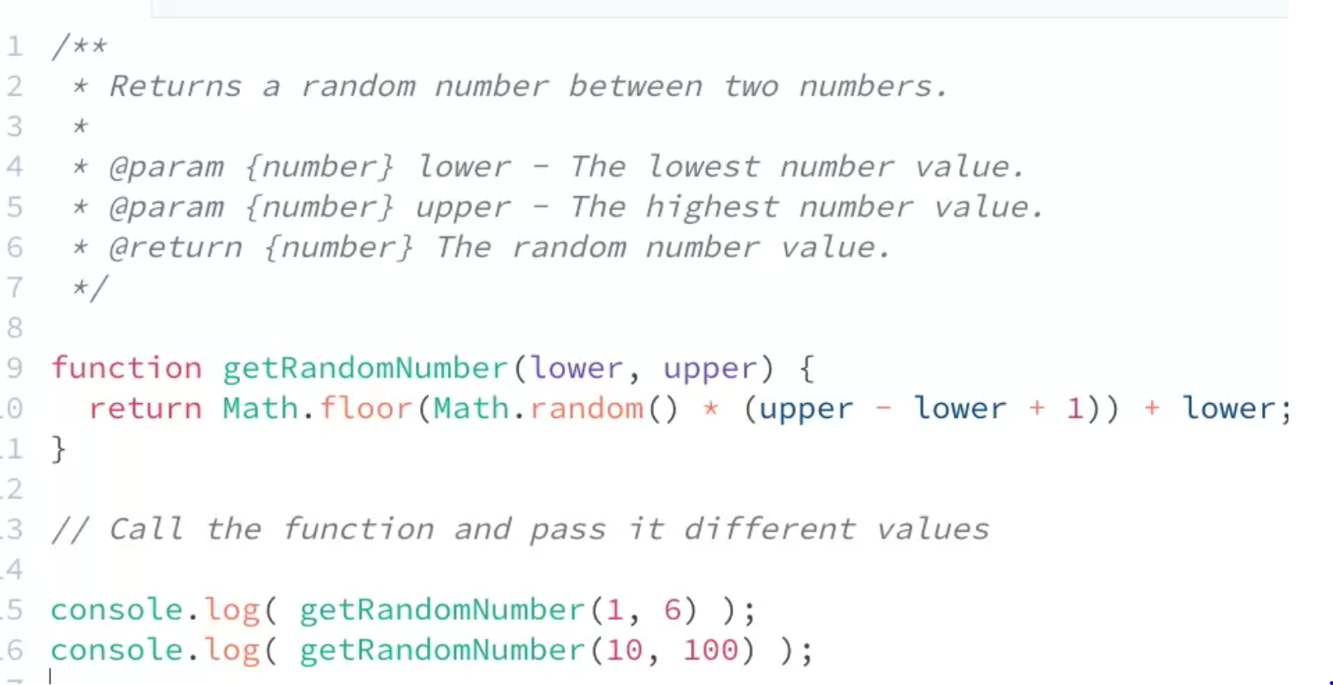

**JAVASCRIPT LOOPS**

* A loop is a way to repeat the same set of actions a certain number of times or until a specific condition is true
* Increment operator (++), adds 1
  + Counter += 1; = counter++;
* Decrement operator (--), subtracts 1
  + Counter--;
* Avoiding Infinite loops:
  + - <https://www.digitalocean.com/community/tutorials/using-while-loops-and-do-while-loops-in-javascript>
  + (break) lets you exit a loop
  + Have a condition that exits a loop once condition is met
* While Loop: creates a loop that executes a specified statement as long as the test condition evaluates to true. The condition is evaluated before executing the statement.
  + <https://developer.mozilla.org/en-US/docs/Web/JavaScript/Reference/Statements/while>

* Do While Loop:  creates a loop that executes a specified statement until the test condition evaluates to false. The condition is evaluated after executing the statement, resulting in the specified statement executing at least once. Condition is tested after the code block.
  + <https://developer.mozilla.org/en-US/docs/Web/JavaScript/Reference/Statements/do...while>

* For Loop: creates a loop that consists of three optional expressions, enclosed in parentheses and separated by semicolons, followed by a statement (usually a [block statement](https://developer.mozilla.org/en-US/docs/Web/JavaScript/Reference/Statements/block)) to be executed in the loop.
  + <https://developer.mozilla.org/en-US/docs/Web/JavaScript/Reference/Statements/for>
  + condition 1 is tested before loop begins
  + condition 2 is tested before loop begins, this is the condition that prevents the loop from being an infinite loop
  + condition 3 is a a counter that keeps track of the loop iterations in a physical form

Displays 10 random numbers in the console:

Displays numbers from 5-100 counting by 5’s on the web page:

Gives user 5 times to guess the secret word, but doesn’t exit once the word is guessed, the loop continues to run until user has guessed 5 times

This loop gives the user 5 guesses but stops once the secret word is guessed

This loop asks a user if they want to continue until launch, if user types “y” in dialog box then the program continues until the test condition is no longer true, then it exits the program or “liftoff”, if the user types “n” then the program exits or “abort launch”

This loop displays number 1-10 on the webpage with different colors as the background, that random numbers determine the RGB of the background

Same loop, refactored

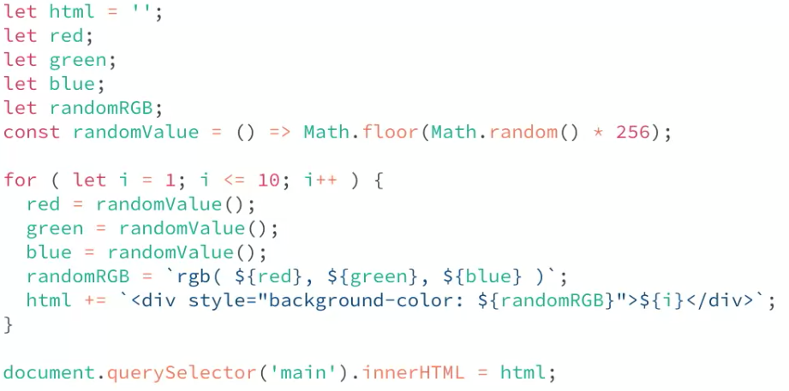

Refactored again

**JAVASCRIPT ARRAYS**

* <https://developer.mozilla.org/en-US/docs/Learn/JavaScript/First_steps/Arrays>
* a neat way of storing a list of data items under a single variable name.
  + let varName = []; can put strings or numbers inside an array
  + to find an item in an array, declare the variable name and find it using its place number or index. The array starts at 0

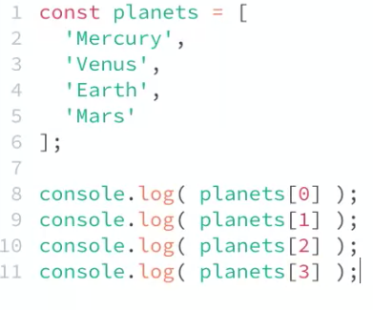

* properties you can use with arrays
  + .length; shows how many values are being stored in an array
  + .push(); places one or more values at the end of an existing array
  + .unshift(); places one or more values at the beginning of an array
  + .pop(); removes the last item from the end of an array, doesn’t take an argument
  + .shift(); removes the first item from the end of an array, doesn’t take an argument
  + .join() returns the contents of an array as one string separated by commas
    - Usually pass the parameter a string that you want the elements to be separated by, default is a comma
  + .includes() determine whether an array includes a certain value among its entries and returns either true or false
    - Parameter passed is the value you are searching for
  + .indexOf(); to return the index, position of a certain value inside an array
    - Parameter passed is the value of whos index you are looking for. When a value is not in an array, this returns -1 because it is not in the array
  + Math.max(varName);
  + Math.min(varName);
  + Spread operator (…)
    - Spread creates a copy of the original array, and properties do not affect it unless explicitly called

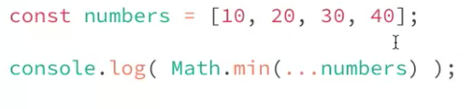

* Using a for loop to iterate through an array

Prompts user to ask for a a grocery in stock and displays an answer on the web page

* multidimensional arrays
  + <https://developer.mozilla.org/en-US/docs/Web/JavaScript/Reference/Global_Objects/Array#creating_a_two-dimensional_array>

**JAVASCRIPT OBJECTS**

* Obtain properties and methods: A property is like a variable that belongs to the object, and a method is something the object can "do," or that can be "done" to the object. An array is an object
  + Object literals: <https://developer.mozilla.org/en-US/docs/Web/JavaScript/Guide/Grammar_and_types#object_literals>

* + - Accessing info in an object:



* + - Changing info in an object and adding new info into an object

* + - Accessing a property value and displaying all the values in the console

* + - Creating object literals inside an arrayA screen shot of a computer code

      Description automatically generated with low confidence

